Guideline

1. Copy the extension file(public) to the desired folder.

2. Launch the new Google Chrome.

3. Click Customize and control Google Chrome/Extensions/Manage extensions in the upper right corner of Google Chrome.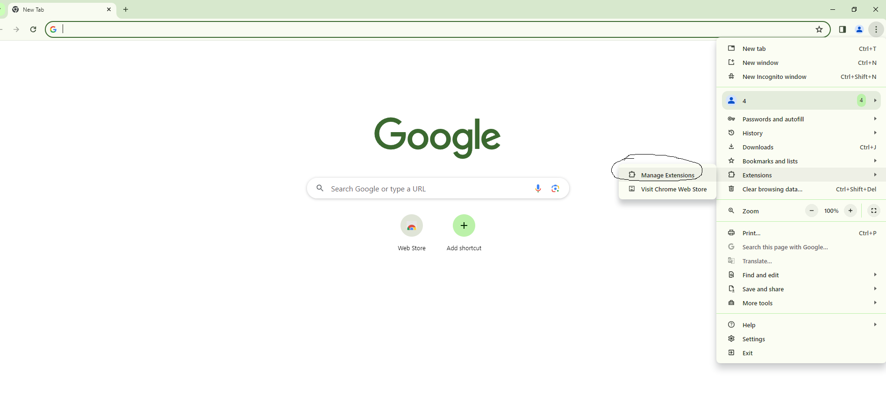

Figure 1

4. Click the “Developer Mode” switch button on the screen

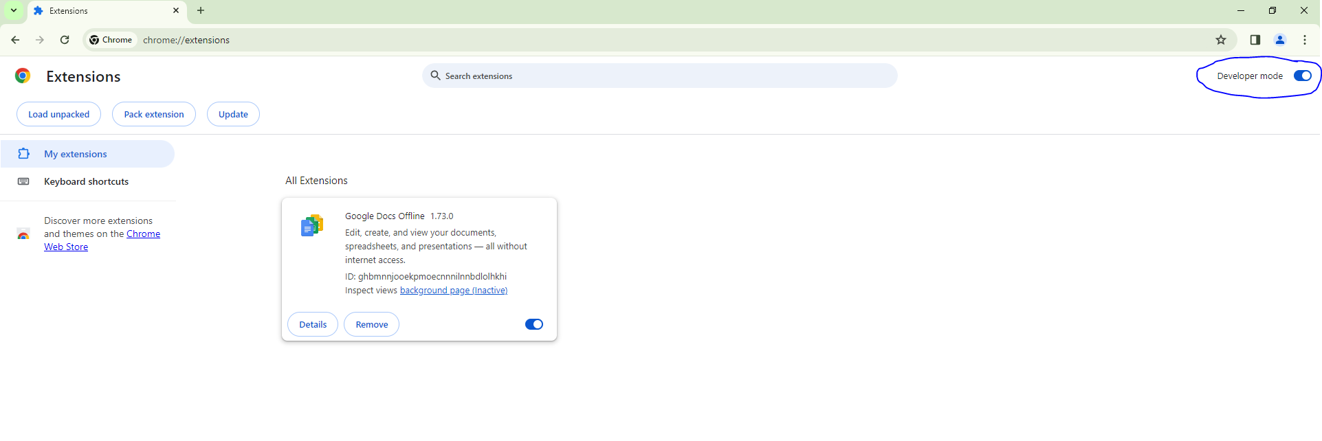

Figure 2

1. Click the “Load unpacked” button.

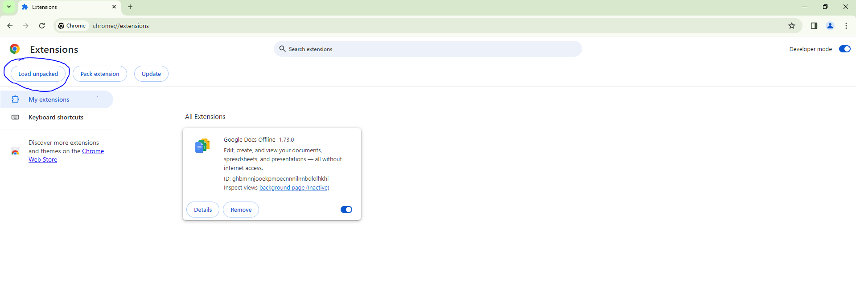

Figure 3

1. Select extension folder(public) as figure and click the select folder button

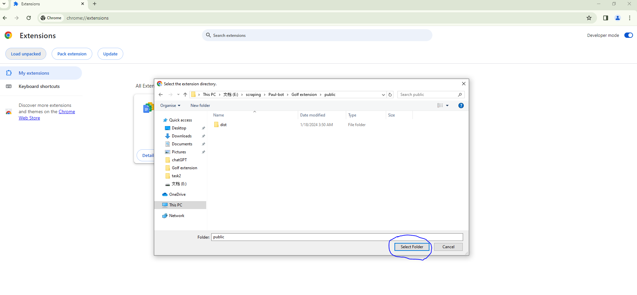

Figure 4

1. Create new tab on the google chrome.
2. Log in to the golf website.

Here you will see the Booking extension on the right. 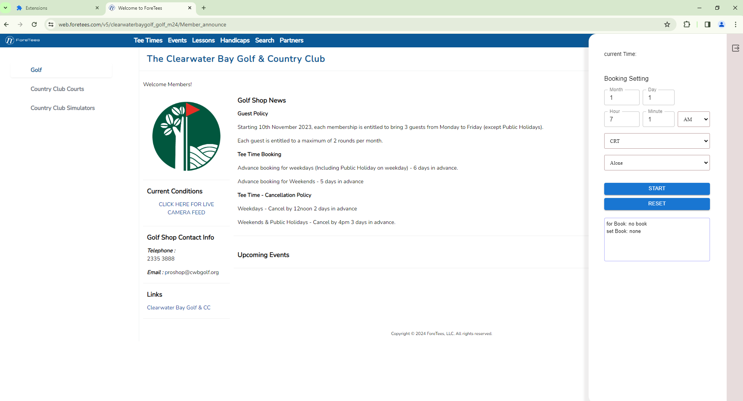

Figure 5

1. Open the Extensions tab.
2. Click the refresh button in React Chrome Extension Template. 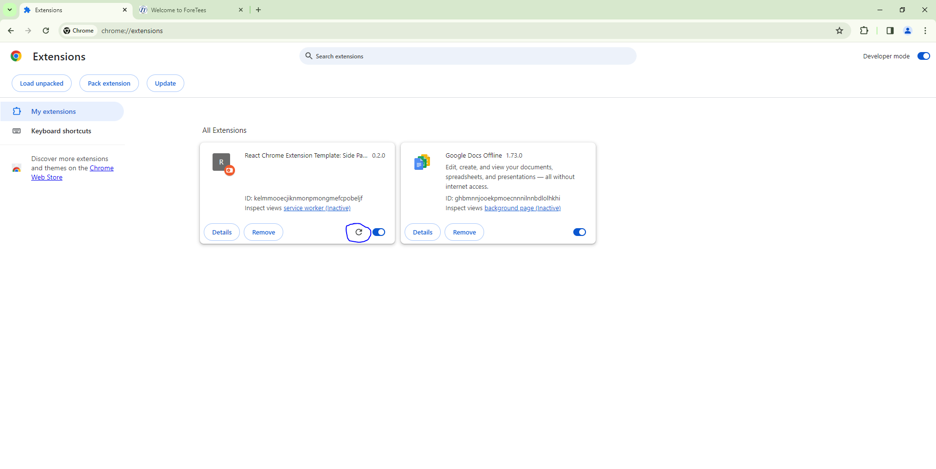

Figure 6

1. Click the reset button. 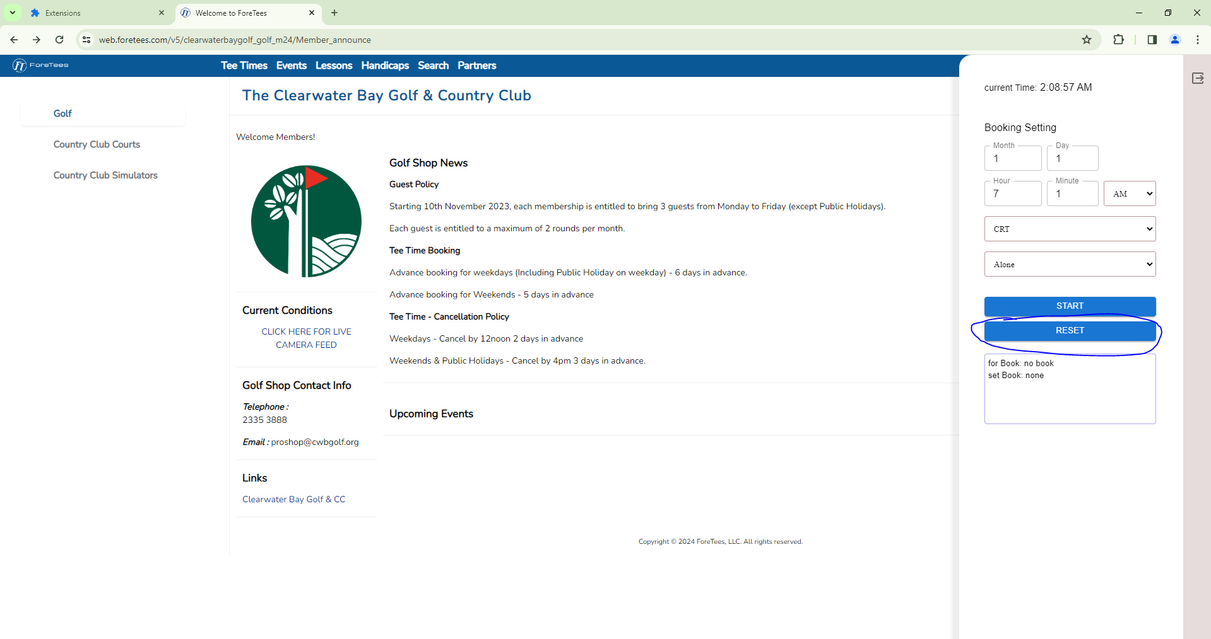

Figure 7

1. Visit the booking page. 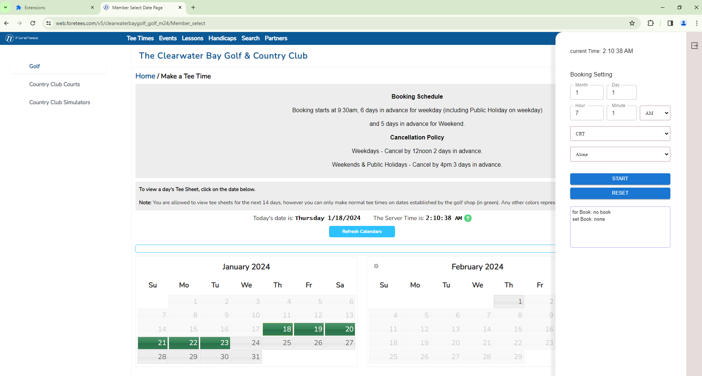

Figure 8

1. Set the booking conditions.
2. Finally click on the start button.   
   Then the bot works and wait until 9.30 AM. 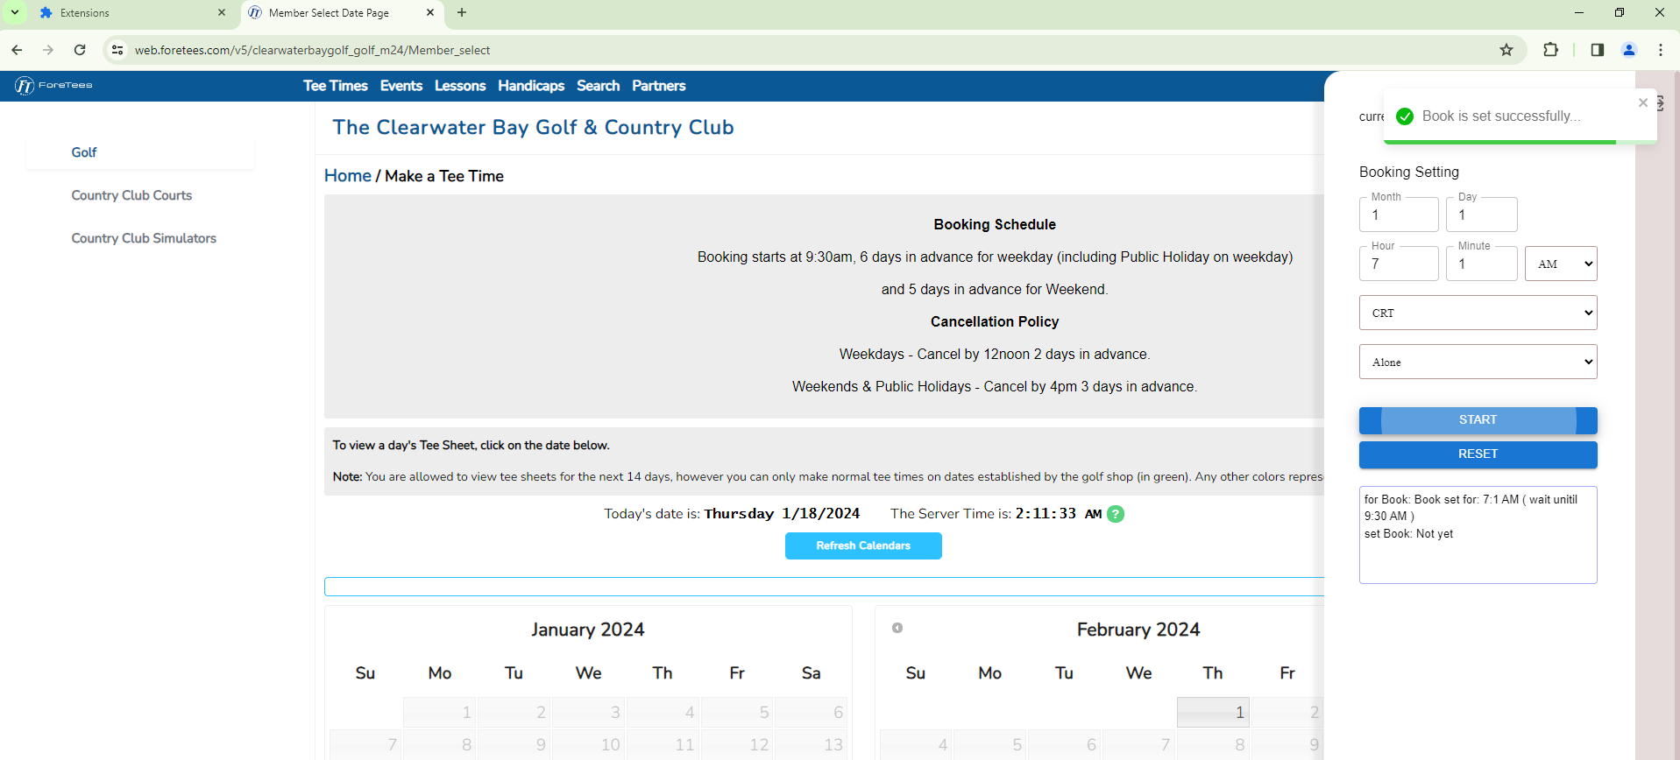

Figure 9